# Check the current value

cat /proc/sys/vm/swappiness

# Define the new one

sysctl vm.swappiness=0

# Disable SWAP, it'll take some times to clean the SWAP area (of the order of 15 minutes)

swapoff -a

# Check if well applied

cat /proc/sys/vm/swappiness

The execution in the JS Shell from Proxmox:

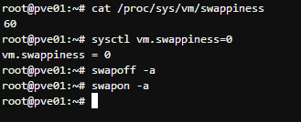

In /etc

nano sysctl.conf

and at the end add:

vm.swappiness = 0

and reboot.

There is still and 8GB swap file, but its use will only be in an emergency.

For other options, like removing swap, see:

<https://gist.github.com/mrpeardotnet/e6bc57ed899c948ba53b3193a202eb2c>